**Project Final Report**

Nam Phan – 300296406

Gurkaran Singh – 300293305

Divya Gupta – 300297998

Krishma Sukhija – 300297902

Project Name:   
Cruise Booking Web App

**CSIS 3275  
Instructor: Ivan Wong  
Winter 2020**

**April 9, 2020**

# 

# Software Scope

We have created a web solution for booking cruise trips for individuals and families. There are not enough sites related to this area, so our product tries to explore it. We connected with the major cruise vendors in the Vancouver area and recruited them into a consortium. This makes our application a one-stop shop for booking cruise trips.

Our target users are families and individuals looking for a luxurious stay at a cruise to enjoy their time. There is a dearth of options to book cruise trips of such nature. The aim of this project is to give customers more options such as selecting destinations, rooms based on the view they like, activities they would like to perform, a view of route map and many other things.

The closest system comparable to ours is Disney Cruise. The strength of Disney’s system is the brand recognition and the lack of competition in this field helps them as well. The major weakness of their system is that it does not cater to many people. There are not enough cost options available from Disney. Our system will improve the shortcomings of Disney’s system by providing more cost options. Users will be able to pick and choose what package fits their budget and still get a good deal.

The major functionalities of our application include:

* Displaying the cruise available : The user has the option to select cruise of their choice from the available cruises.
* Display Route details : the user can view the map and see the routes
* Selecting Room type : Different rooms with different views (like Oceanview , verandah) are available .
* Room Booking : Customer has the choice to reserve rooms based on the number of guests
* Display Activity detail : The cruise offers different activities to entertain the customers like Beverage Tastings , Pirate Night .
* Displaying Booking Summary : Once the booking is confirmed a summary of what all the user has reserved (in terms of rooms , cruise ) is displayed in this feature .
* Invoice : summary of the customers expenses on the invoice page .
* Admin Interface: Statistics

The application opens with a Login page that leads right into the Display Routes page that offers an array of options for our users to choose. Once the route is selected, the user is then presented with the option of selecting a room they want to stay in. Once picked, the customer can then pick and choose what activities they might indulge in on the vacation. Finally, they are given a summary of their expenses on the Invoice page. We also have an Admin page that allows the vendors to check the reports on their bookings.

### Why the user would want to use our software:

* **Usability:** Our website is designed to solve the purpose of booking the cruise trips online. It is kept easy to access and use which gives seamless user experience.
* **Relevant content:** We have kept the useful contents that make it better for user to solve their needs like we have kept textual description for cruises, room type, activities etc. Moreover, the pictures and videos also aid user in making a better selection.
* **Clear navigation:** The website has clear steps which user can follow in order to fulfill their needs. The flow of the website components is what makes it simple and user can move sequentially through the features to make their bookings. The navigation includes selecting the cruise, choosing the route, making a choice of the room type and choosing room number from the list of rooms. Lastly, checking the activities they want to use and at the end a user can have the summary of their booking.
* **Good visual appeal:** The overall look and feel of the website is appealing for the user. The design is simple yet relates to its purpose. We have tried to add visualizations for all the important content that ease the decision making.

### Use Case Diagram

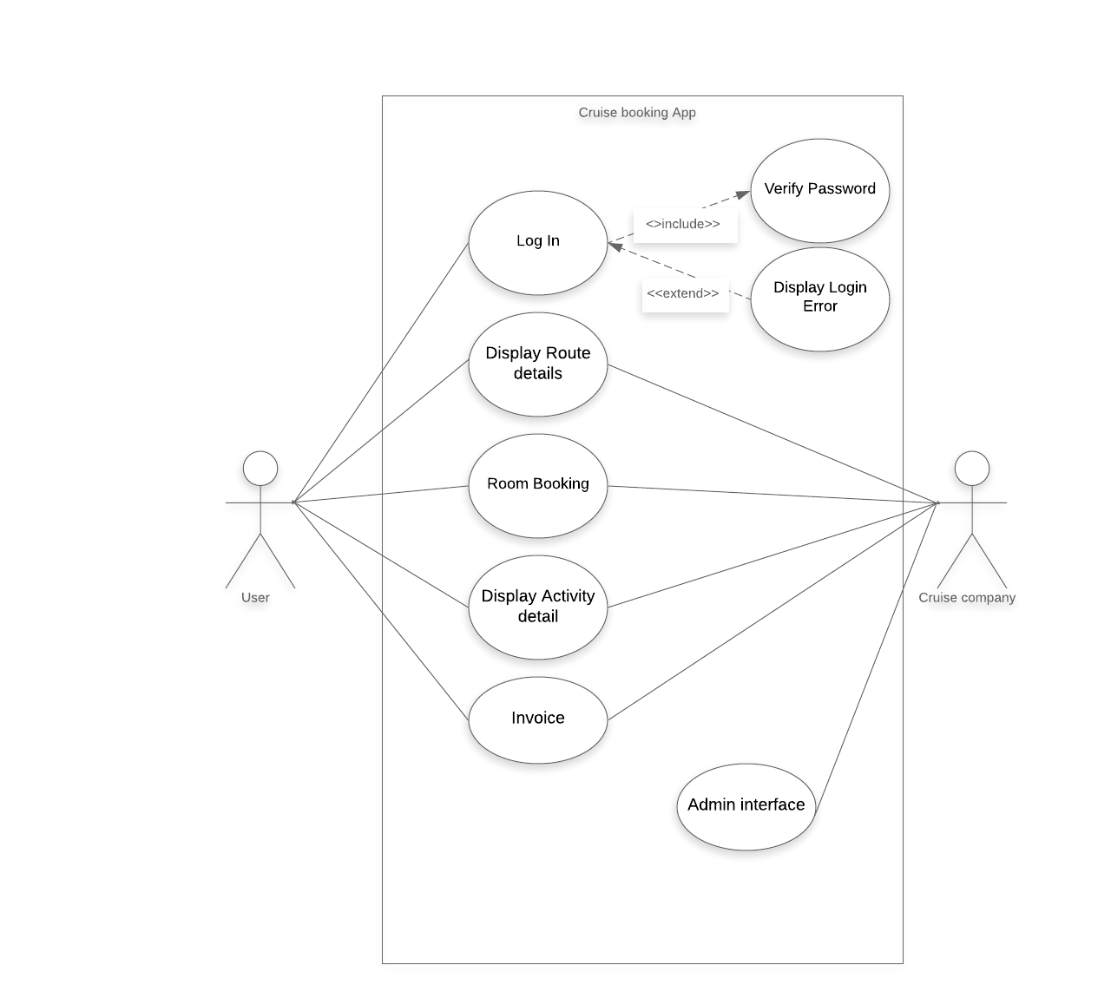

### UI Diagrams

## Display Route details

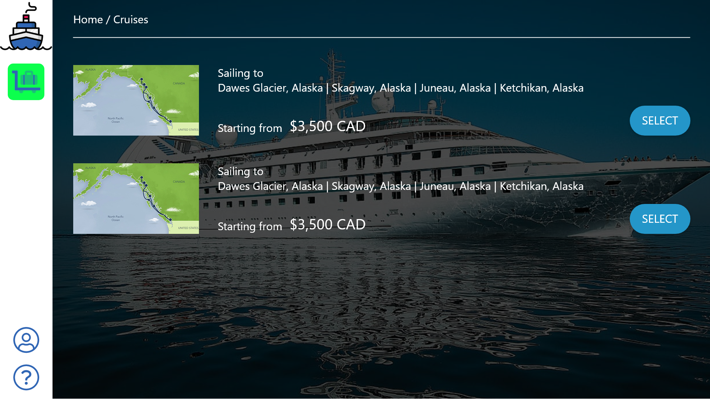

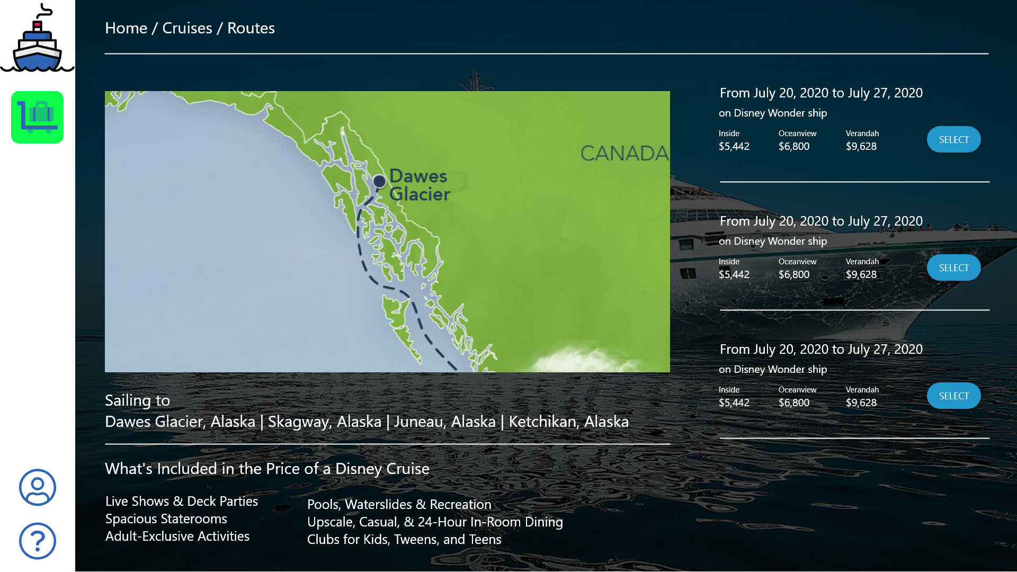

## 

## Room Booking

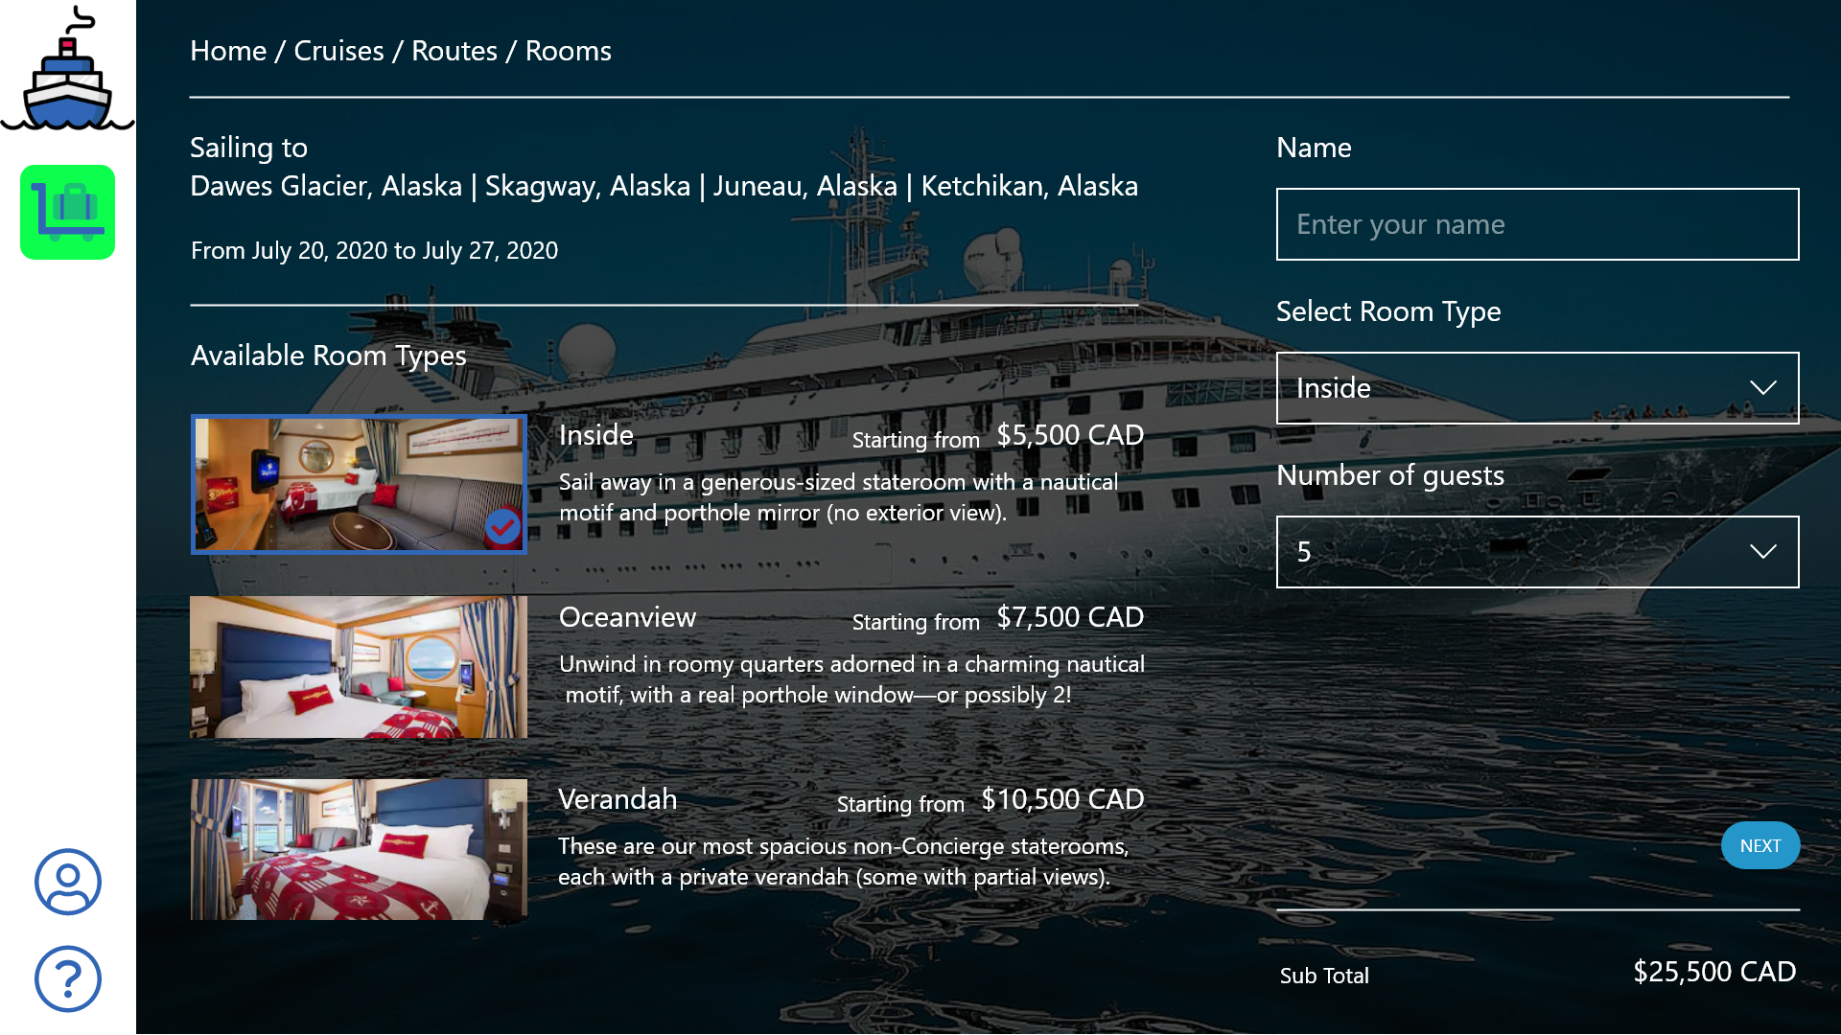

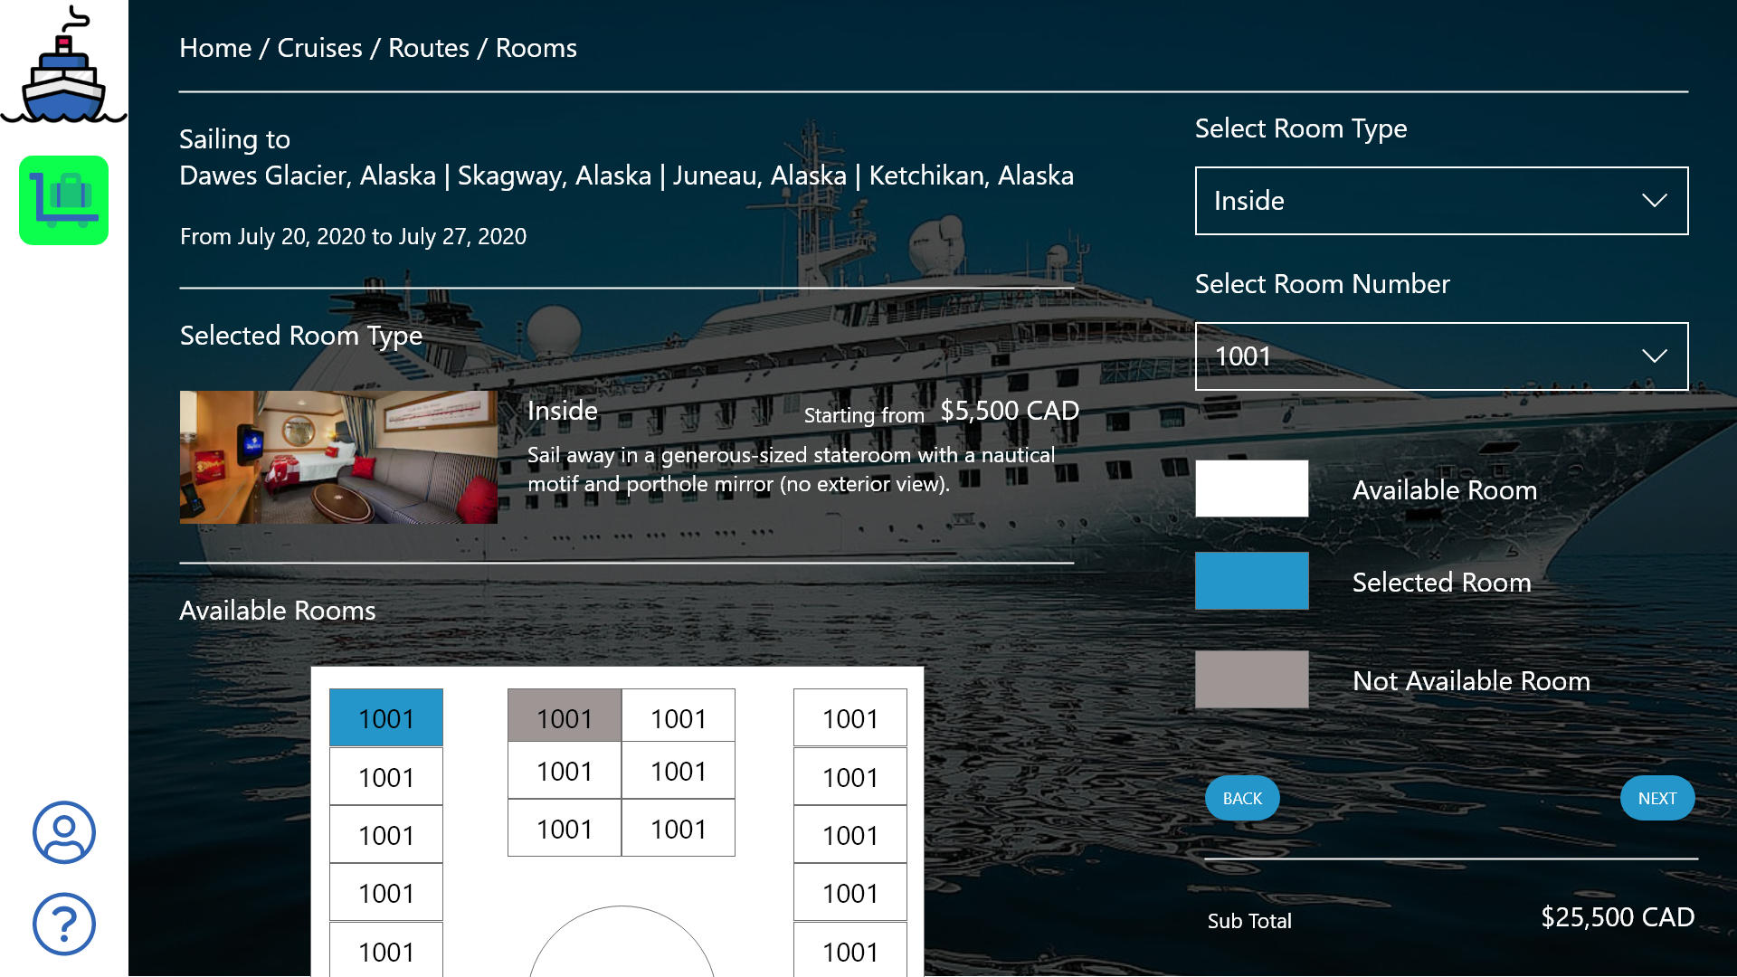

# Group Dynamics

The person the team has chosen to serve as the Project Manager (PM) is Gurkaran Singh as he has previous experience of working with everyone else in the group. The main developer of the project is Nam Phan as he has years of work experience as a professional developer. Karishma and Divya have been allotted the design work as they have worked on the same team and have a mutual understanding of each other’s work.

The whole team will be part of the testing phase and if one person is unable to do their job, we pitch in to help as we can. Disagreements can arise in any team and in our team, we solve them by communicating regularly. We meet every week to take note of our progress and iron out any problems we may be facing. We put forth our opinions respectfully but, eventually, go with the team’s mandate.

# Schedule / Timeline

# 

Rough schedule for project completion

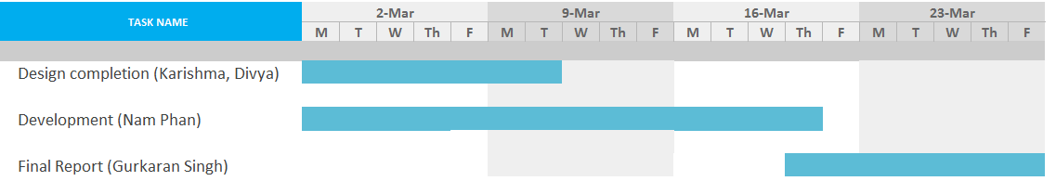

# Risk

**Estimation and scheduling**

Due to the nature of the project and the team’s schedules, there are bound to scheduling conflicts. Requirements may not be completely accounted for due to disjointed and short meetings. This may lead to development problems down the line as the development phase gains pace. The erstwhile busy schedules of the members may also hamper their productivity and, thus, delay the project.

**Technical risks**

Sometimes software development firms reduce the functionality of the software to compensate for overruns pertaining to high budgets and scheduling. There is always a conflict between achieving maximum functionality of the software and peak performance. In order to compensate for excessive budget and schedule overruns, companies sometimes reduce the functionality of the software.

**Unavoidable risks**

There might be changes in the government policy, the obsolescence of software or other risks that cannot be controlled or estimated. As the field of software development becomes more and more complex, the risks associated with it have intensified. It is vital that development firms focus on strategic planning to mitigate such risks.

**Breakdown of specification**

During the initial phases of integration and coding, requirements might conflict. Moreover, developers may find that even the specification is unclear or incomplete.

**Among these the most worried risk is Technical risk**

It is difficult to make websites perfectly in a way that they function well on every type of browser, screen size and different orientations. The composition for them are infinite. As optimization for a specific group can cause de-optimization for another.

* Measures performed to reduce the risk:
* Recognizing the important areas of concern and measuring the probability of risk occurrence.
* Prioritizing and categorizing the risk based on how much bigger impact they have.
* Analyzing the security requirements such as authorization and authentication.
* Identifying software and hardware risk.
* Responding to the risk and trying to minimize their negative effect.

In order to reduce this kind of risk we are trying to ensure that the application is standards-compliant and optimized for at least the important latest/current platforms and versions. Keeping in mind that perfect stability across all is virtually unattainable.

# 

# Project Logs

|  |  |  |  |  |
| --- | --- | --- | --- | --- |
| **Date** | **Tasks** | **Members involved** | **Description** | **Duration** |
| January 20th | Meeting for proposal | Nam Phan, Gurkaran Singh, Divya Gupta, Krishma Sukhija | Discussion for possible topic of project | 1 hour |
| January 22nd | Proposal writing | Nam Phan, Gurkaran Singh, Divya Gupta, Krishma Sukhija | Writing proposal | 1.5 hours |
| January 25th | Requirement gathering and analysis | Nam Phan, Gurkaran Singh, Divya Gupta, Krishma Sukhija | Discussion and analysis of requirements | 2 hours |
| January 31st | Workflow distribution | Nam Phan, Gurkaran Singh, Divya Gupta, Krishma Sukhija | Decisions made on team roles and work distribution | 1 hours |
| Feb 01st | Design – Modeling Phase | Nam Phan, Gurkaran Singh, Divya Gupta, Krishma Sukhija | Discussion for design modeling based on requirements | 2 hours |
| Feb 08th | Design – Implementation Phase | Gurkaran Singh, Divya Gupta, Krishma Sukhija | Starting the implementation of the model | 1.5 hours |
| Feb 13th | Design – Implementation Phase II | Divya Gupta, Krishma Sukhija | Continuing the implementation process | 2 hours |
| Feb 17th | Team Discussion | Nam Phan, Gurkaran Singh, Divya Gupta, Krishma Sukhija | Tracking the progress of the project | 45 minutes |
| Feb 23rd | Development – Initial stage | Nam Phan, Gurkaran Singh | Beginning the development phase based on initial designs | 1 hour |
| Feb 26th | Project Interim Report | Gurkaran Singh, Divya Gupta, Krishma Sukhija | Writing the Project Interim Report | 1.5 hours |
| Mar 1st | Project Interim Report | Gurkaran Singh, Nam Phan | Finishing the Project Interim report – compiling all the data | 2 hours |
| Mar 7th | Database  Creation | Gurkaran Singh, Nam Phan | Working on database create queries | 2.5 hours |
| Mar 12 | Database insertion | Krishma Sukhija,  Divya Gupta,  Nam Phan, Gurkaran Singh | Working on populating the database with values | 2 hours |
| Mar 14 | Database  Refinement | Nam Phan, Gurkaran Singh | Completing database and working on database connectivity | 2 hours |
| Mar 22 | Admin Design | Nam Phan, Gurkaran Singh | Creation of the admin side of the  project | 2.5 hours |
| Mar 25 | Database  Insertion | Krishma Sukhija, Divya Gupta | Inserting more database queries | 2 hours |
| April 1 | Project Final Report | Divya Gupta, Krishma Sukhija | Working on the final report | 1.5 hours |
| April 5 | Project Final Report | Nam Phan, Gurkaran Singh | Working on final repGort | 1.5 hours |
| April 6 | Presentation Preparation | Krishma Sukhija, Divya Gupta | Working on  group presentation | 1 hour |
| April 7 | Presentation completion | Nam Phan, Gurkaran Singh | Working on  Group presentation | 1 hour |

# Contribution

Gurkaran Singh – As a PM, he has organized meetings, worked on the reports, kept a work log and tracked the progress of the project.

Nam Phan – As a developer, he has laid the foundation of the project’s backend. He has also worked on the reports and worked on the UI of the application.

Krishma Sukhija – As a designer, she has worked on the initial stages of designing the application along with Divya. She has also worked on the report and made the schedule and timeline.

Divya Gupta – As a designer, she worked with Karishma on the initial stages of designing the application. She has also worked on the report and analyzed the risks faced by the project.

# Resources

**Presentation Video**

<https://drive.google.com/file/d/1uoahu4ec3LsOObeeifSfBbg4gxt4_q_Q/view>

**Github**

<https://github.com/namphan47/3275-Cruise-Project>

**Installation Instruction**

1. Prerequisites
   1. Window OS
   2. Internet
   3. Eclipse IDE <https://www.eclipse.org/downloads/>
   4. JRE System Library [J2SE-1.5
2. Steps
   1. Download zip file
   2. Unzip the file
   3. Open Eclipse IDE
   4. Open the project under 3275-Cruise-Project/project/
   5. Right click to the project, select Run As/Run Configuration
   6. Set Goals: jetty:run
   7. Click Run